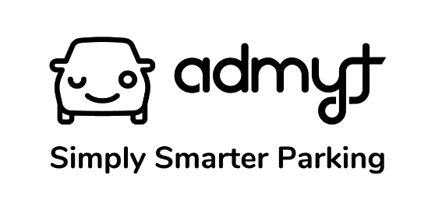

Competition Terms and Conditions
1. Competition Promoter
This competition is run by admyt ("Promoter").
admyt offers ticketless parking services to its registered users at certain shopping centres, retail parks, corporate office parks and other parking facilities (“Centres”). The admyt services include ticketless entry and exit to and from Centres, special offers (including vouchers and coupons) from retailers, brands or partners (or partner programs) in each Centre and free, discounted or extended parking (subject to conditions) (collectively the “Services”).
2. Eligibility
2.1 This competition is open to all South African residents over the age of 18 ("Entrants"). 2.2 Employees of the Promoter, their immediate family members, and any entities directly associated with this competition are excluded from entering.
3. Competition Period
The competition will run from 26 April 2024 to 27 April 2024 ("Competition Period"). Entries outside this period will not be considered.
4. How to Enter
4.1 To enter the competition:
Entrants must sign up for an account on admyt and park at Blue Route Mall during the competition period (26 - 27 April 2024).
5. Prize
5.1 There are two (2) prizes available to be won. 5.2 Each prize consists of a R500 Checkers gift card. 5.3 The prize is non-transferable and there is no cash alternative. 5.4 The prize needs to be collected at Blue Route Mall in-person.
6. Winner Selection
6.1 Winners will be selected randomly from all valid entries during the Competition Period. 6.2 The draw will take place on 2 May 2024 and the winners will be notified by phone call or email within the first week of the draw.
7. Claiming the Prize
7.1 Winners must claim their prize within 14 days of being notified. 7.2 To claim the prize, winners must respond to the notification and provide any necessary information requested by the Promoter. 7.3 If a winner does not claim their prize within the specified timeframe, the Promoter reserves the right to redraw the prize. The prize must be collected in-person at Blue Route Mall centre management.
8. Data Protection
8.1 By entering this competition, Entrants agree to their personal information being used by the Promoter for the purposes of running the competition. 8.2 Entrants' personal information will not be shared with any third party without their consent. 8.3 Entrants can request access to their personal information or request its deletion at any time by contacting the Promoter at hello@admyt.com.
9. General
9.1 The Promoter reserves the right to amend these terms and conditions at any time without prior notice. 9.2 The Promoter's decision on all matters relating to the competition is final and no correspondence will be entered into. 9.3 This competition is in no way sponsored, endorsed, or administered by, or associated with, the social media platform(s) it is run on.
10. Disclaimer
The Promoter is not responsible for any technical errors, malfunctions, or failures of any kind that may prevent entries from being received or processed.

